**The role of edge computing in enabling efficient and secure IoT for 5G**

***Kartikey Bhardwaj1***\****, Jinendar Kothari2 and Amita Agnihotri3***

1-2Department of ECE, Inderprastha Engineering College, Ghaziabad, Uttar Pradesh, India

3Department of ECE, , Ghaziabad, Uttar Pradesh, India

***Abstract***

*The integration of the Internet of Things (IoT) with 5G technology has the potential to transform the way we live and work, enabling a wide range of new applications and services. This paper explores the capabilities of 5G technology and how it can be leveraged to support IoT applications in various industries, including healthcare, transportation, and manufacturing. The paper also discusses the challenges and opportunities that arise from the combination of IoT and 5G, such as security concerns, network architecture, and scalability. Additionally, the paper provides an overview of the latest research and development in the field and the future prospects for IoT in 5G. Overall, the paper demonstrates the significant potential of IoT in 5G and highlights the need for continued research and development in this field to enable the full realization of the technology's benefits.*

***Keywords:*** *Wireless networks, Smart cities, Industrial IoT, Healthcare IoT, 5G.*

\****Author for Correspondence*** E-mail: kartik01bhardwaj@gmail.com, Tel: +91 819180004

**INTRODUCTION**

The fifth-generation (5G) of mobile networks promises to revolutionize the way we connect and communicate, enabling the development of new applications and services with unprecedented speed, reliability, and capacity. The Internet of Things (IoT) is expected to be a key beneficiary of 5G, with billions of devices and sensors generating massive amounts of data in real-time. However, this presents significant challenges for network infrastructure, as traditional centralized cloud computing architectures may not be able to handle the volume and complexity of IoT data, leading to latency, bandwidth, and security issues. Edge computing has emerged as a promising solution to address these challenges, by enabling distributed processing and storage of data at the network edge, closer to the IoT devices and users. In this paper, we explore the role of edge computing in enabling efficient and secure IoT for 5G, by examining the benefits, challenges, and future directions of this emerging paradigm. We argue that edge computing is a critical enabler for the success of IoT in 5G, and highlight the need for further research and development in this area to unlock the full potential of this transformative technology.

**INTERNET OF THINGS (IOT) FOR 5G**

**Iot Definition**

IoT, or the Internet of Things, is a network of interconnected devices that extends beyond traditional boundaries to connect people, places, and things. The concept of IoT has been defined by the International Telecommunications Union (ITU) as a global infrastructure that interconnects physical and virtual things using interoperable communication technologies to enable advanced services. In recent years, IoT has gained immense popularity and its applications have expanded to encompass various dimensions, such as any Thing, any Place, any Time, any Body, etc. To establish interoperability among IoT devices and transform the world into a global village, standardization efforts have been undertaken by various organizations and institutes, which will be discussed in the following sections.

**Standardization Effort**

Standardization is crucial for regulating any system's operations and ensuring interoperability among various components. Various standardization authorities worldwide have initiated efforts to create relevant standards for IoT during the last decade. However, the diverse and dynamic nature of IoT has made it challenging to unify these standards into a single framework. As a result, several organizations, institutions, and groups have become involved in IoT standardization efforts, as listed in Table 1 [1]. IEEE has also established several persuasive IoT-related standards, which are listed in Table 1 [2].

|  |  |  |
| --- | --- | --- |
| IEEE 802.11-2012 | The exchange between systems–Local and metropolitan area networks–Specific requirements Part 11: Wireless LAN Medium Access Control (MAC) and Physical Layer (PHY) specifications Amendment 10: Mesh Networking | |
| IEEE 802.15.4-2011 | Networks–Part 15.4: Low-Rate Wireless Personal area networks (LR-WPANs) | |
| IEEE 802.15.4g-2012 | Networks–Part 15.4: Low-Rate Wireless Personal Area Networks (LR-WPANs) Amendment 3: Physical Layer (PHY) Specifications for Low-Data-Rate, Wireless, Smart Metering Utility Network | |
| IEEE  802.15.7-2011 | IEEE Standard for Local and Metropolitan Area Networks–Part 15.7: Short-Range Wireless Optical Communication Using Visible Light | |
| IEEE  802.16-2012 | IEEE Standard for Air Interface for Broadband Wireless Access Systems | |
| IEEE 802.16p-2012 | IEEE Standard for Wireless MAN-Advanced Air Interface for Broadband Wireless Access Systems – Amendment: Enhancements to Support Machine-to-Machine Applications | |
| IEEE  802.16.1b-2012 | IEEE Standard for Wireless MAN-Advanced Air Interface for Broadband Wireless Access Systems – Amendment: Enhancements to Support Machine-to-Machine Applications | |
| IEEE  1609.11-2010 | IEEE Standard for Wireless Access in Vehicular Environments (WAVE)–Over-the-Air Electronic Payment Data Exchange Protocol for Intelligent Transportation Systems (ITS) | |
| IEEE  1888-2011 | IEEE Standard for Ubiquitous Green Community Control Network Protocol | |
| IEEE  1901-2010 | | IEEE Standard for Broadband over Power Line Networks: Medium Access Control and Physical Layer Specifications |
| IEEE  1905.1-2013 | | IEEE Draft Standard for a Convergent Digital Home Network for Heterogeneous Technologies |
| IEEE 11073-10103-  2013 | | IEEE Standard for Health Informatics – Point-of-care medical device communication -Nomenclature – Implantable device, cardiac |
|  | |  |

*Table 1: Standardization efforts for IoT by different groups of IEEE*.

The emerging IoT architecture can handle the characteristics of the future-generation 5G network, which is expected to connect 50 billion devices to the cloud by 2020. The 5G network will increase the number of devices, data rate, and data volume by 10-100 times, while also increasing device battery life by 10 times and decreasing latency by 5 times. The 5G network incorporates important technologies like radio access, MIMO, mobility management, interference management, and massive spectrum to achieve compatibility with IoT.

To address various issues with these technologies, the METIS project has proposed mechanisms such as D2D communications, which helps maintain an ultra-large-scale network using flexible infrastructure, and massive machine communication (MMC), which interconnects a vast number of devices across different smart technologies. Additionally, proposed solutions for mobility management, interference mitigation, and capacity achievement include moving network (MN), ultra-dense network (UDN), and ultra-reliable network (URN).

Numerous studies on different services for IoT have been conducted, including the M2M-based communication architecture for cognitive radio networks demonstrated in Figure 10. The network layer, which is primarily a communication network, maintains the relationship between the infrastructure layer (including M2M devices and gateway) and the application layer (comprising users, management interface, and the M2M server). The M2M server integrates the entire system for necessary services such as traffic management and smart healthcare systems. The object database (DB) also sends user information in the form of SMS, email, video, etc. The network layer, consisting of a WPAN/WLAN network and an IoT gateway, connects the user interface with the management interface, which monitors user data, takes initiatives as necessary, and informs the relevant body about the situation.

**IoT Architecture**

As the number of connected devices grows, the architecture of IoT is evolving to support the demands of future 5G networks. 5G promises improved Quality of Service (QoS), high capacity, and enhanced data rates, with a sustainable architecture to support these features. D2D communication is a key aspect of 5G networks and can be seen as a manifestation of the IoT concept, which encompasses smart sensors, RFID, machine-to-machine (M2M) communication systems, and IP technologies. This section of the paper focuses on emerging IoT architectures that are suitable for next-generation 5G networks.

The evolution of IoT architecture has followed the development of the Internet. Initially, communication among computers was limited to computer networks, but the World Wide Web (WWW) was launched in 1991, connecting computers worldwide. Subsequent technological advancements connected various types of electronic devices to the cloud network, bringing users under the same platform. Finally, IoT was conceived to connect everything. IoT architectures can be classified into different types due to the complexity of merging architectures proposed for various IoT applications into a single model.

A scheme for classifying IoT architectures is presented in Figure 1. Some authors have proposed three-layer-based simple IoT architectures that include an application layer, a network layer, and a perception layer. Middleware-based IoT architectures comprise a greater number of layers, including the coordination layer next to the middleware layer. Additionally, the perception layer offers a shared option for combining other edge technologies and the access layer. Service-oriented architecture (SOA) has five layers, namely the objects layer, object abstraction layer, service management layer, service composition layer, and application layer. Common IoT networks usually have an architecture consisting of five fundamental layers: the objects layer, object abstraction layer, service management layer, application layer, and management layer.

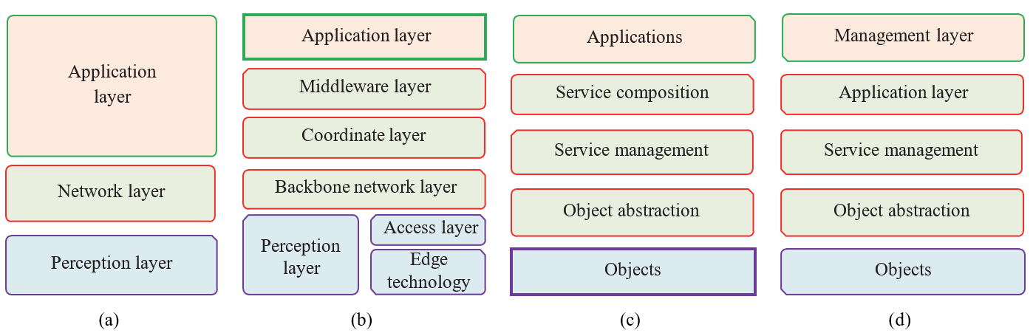

*FIGURE 1: Categorized IoT architectures. (a) Three-layer-based simple architecture, (b) middleware-layer-based architecture, (c) service- oriented architecture (SOA) for IoT, and (d) five-layer architecture (adopted from [3])*

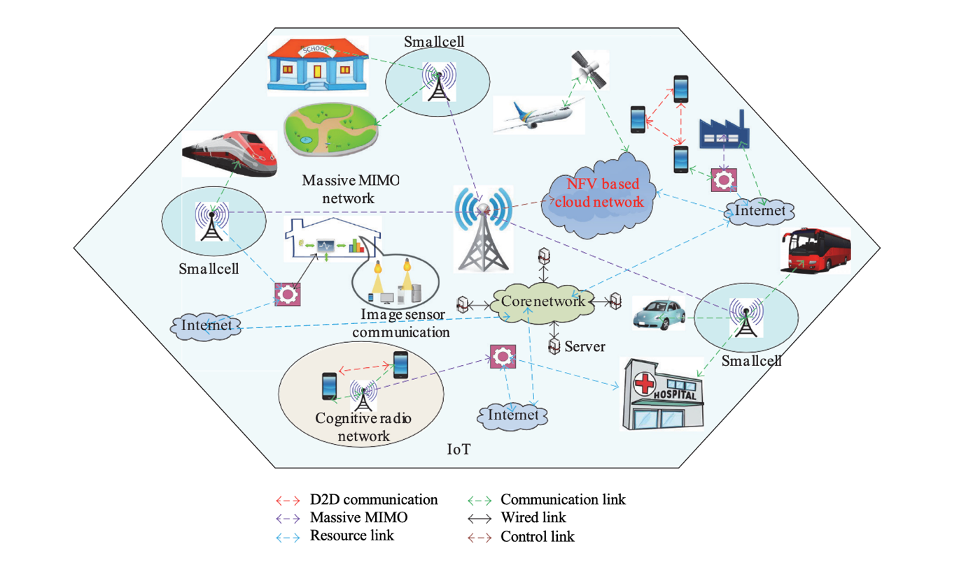

*Figure 2: Simplified future-generation cellular 5G networks*

**Applications**

Smart Healthcare. IoT has brought revolutionary changes in the healthcare system by introducing smart healthcare. IoT technology can be used to monitor patients remotely, track their medication and health conditions, and provide personalized treatment. Wearable devices, such as fitness trackers and smartwatches, can track a patient's vital signs and send them to healthcare providers for analysis [4, 5]. IoT can also improve medication management by providing smart pill bottles that remind patients to take their medication and track their consumption [6].

Industrial Internet of Things (IIoT). IIoT is the application of IoT technology in industries to enhance productivity, reduce downtime, and improve safety. IoT technology can be used to monitor and control industrial processes remotely, provide predictive maintenance, and optimize energy consumption. IIoT can also be used to monitor the health and safety of workers in hazardous environments [7, 8].

Smart Agriculture. IoT technology can be used to monitor crops and livestock, improve crop yield, and reduce water and fertilizer usage. Smart sensors can be used to monitor soil moisture, temperature, and nutrient levels, and send data to farmers for analysis. IoT can also be used to track the health and location of livestock and provide personalized care [9, 10].

Smart Retail. IoT technology can be used to provide personalized shopping experiences, optimize store layout and product placement, and reduce inventory management costs. IoT devices can track customer movements and preferences, analyze shopping patterns, and send personalized offers to customers [11, 12].

These are just a few examples of the numerous IoT applications that are revolutionizing various sectors of our lives. The potential of IoT technology is immense, and it will continue to bring new innovations and opportunities in the future. Overall, the applications of IoT are vast and diverse, and it has the potential to transform almost every sector. From smart homes to smart cities, smart healthcare to agriculture, and industry to environment, IoT has revolutionized the way we live and work. With the help of IoT, we can now remotely control our home appliances, monitor our health, track our vehicles, optimize energy consumption, and much more. Furthermore, IoT has also contributed to improving public safety, disaster management, and weather forecasting. As IoT technology continues to advance, we can expect to see even more innovative applications in the future.

**Challenges and Future Direction**

The challenges of IoT are significant for 5G, as the key features of IoT such as heterogeneity, secure communications, and system protocols have resulted in various challenges. Some of these challenges include the need for large-scale storage due to the different types of data that need to be processed and categorized, computation problems due to the integration of heterogeneous devices, and the challenge of designing a common protocol for connecting heterogeneous devices. Security and privacy have become major concerns, as cloud computing is used for storing data, and personal privacy between numerous devices must be established while maintaining computing power constraints. Reliability has emerged as a serious challenge due to the connectivity of everything, particularly in sectors such as public health, emergency operations, critical disease treatment, smart transportation, and smart homes. Performance varies depending on the different layers and activities of IoT, with certain functions requiring highly assured performance and quality of service, such as traffic mobility, real-time connections, and emergency services.

In the realm of IoT, the advent of cloud computing, big data, and SDN has opened up new avenues for research. Standardization efforts have also had an impact on future research directions. One significant challenge is the integration of devices with different mechanisms onto a single platform that offers massive computational performance and energy efficiency. Security, privacy, and reliability are other important areas that need to be addressed on this platform. In addition to these issues, there are several other aspects of IoT that could be the focus of future research, such as developing intelligent systems for real-time data collection and processing and creating individual social networks for different devices that can be combined into a single IoT platform. Scalability, reliability, and flexibility are also important areas for future research.

**REFERENCES**

1. IERC (European Research Cluster on the Internet of Things) position paper, <http://www.internet-of-things-research.eu/pdf/> IERC Position Paper IoT Standardization Final.pdf.
2. IEEE Standards Association, “Internet of Things Related Stan- dards,” [http://standards.ieee.org/innovate/iot/stds.html.](http://standards.ieee.org/innovate/iot/stds.html)
3. N. L. Geller, D.-Y. Kim, and X. Tian, “Smart technology in lung disease clinical trials,” *Chest*, vol. 149, no. 1, pp. 22–26, 2016.
4. M. R. Abdmeziem and D. Tandjaoui, “An end-to-end secure key management protocol for e-health applications,” *Computers & Electrical Engineering*, vol. 44, pp. 184–197, 2015.
5. B. Xu, L. D. Xu, H. Cai, C. Xie, J. Hu, and F. Bu, “Ubiquitous data accessing method in iot-based information system for emergency medical services,” *IEEE Transactions on Industrial Informatics*, vol. 10, no. 2, pp. 1578–1586, 2014.
6. A. Pantelopoulos and N. G. Bourbakis, “A survey on wearable sensor-based systems for health monitoring and prognosis,” *IEEE Transactions on Systems, Man and Cybernetics Part C: Applications and Reviews*, vol. 40, no. 1, pp. 1–12, 2010.
7. S. R. Moosavi, T. N. Gia, A. M. Rahmani et al., “SEA: a secure and efficient authentication and authorization architecture for IoT-based healthcare using smart gateways,” *Procedia Computer Science*, vol. 52, pp. 452–459, 2015.
8. R. Li, B. Lu, and K. D. McDonald-Maier, “Cognitive assisted living ambient system: a survey,” *Digital Communications and Networks*, vol. 1, no. 4, pp. 229–252, 2015.
9. A. Hussain, R. Wenbi, A. L. Da Silva, M. Nadher, and M. Mudhish, “Health and emergency-care platform for the elderly and disabled people in the Smart City,” *Journal of Systems and Software*, vol. 110, pp. 253–263, 2015
10. S. J. Liu and G. Q. Zhu, “The application of GIS and IOT technology on building fire evacuation,” *Procedia Engineering*, vol. 71, pp. 577–582, 2014.
11. Z. Yinghua, F. Guanghua, Z. Zhigang, H. Zhian, L. Hongchen, and Y. Jixing, “Discussion on application of IOT technology in coal mine safety supervision,” *Procedia Engineering*, vol. 43, pp. 233–237, 2012.
12. E. Sun, X. Zhang, and Z. Li, “The internet of things (IOT) and cloud computing (CC) based tailings dam monitoring and pre- alarm system in mines,” *Safety Science*, vol. 50, no. 4, pp. 811–815, 2012.